Lesson 9-3 Sample Means

# Notes on averages

* Averages are less variable than individual observations.
* Averages are more normal than individual observations.
* The mean and standard deviation of a population are parameters. We use Greek letters to write these parameters: μ for the mean and σ for the standard deviation.
* The mean and standard deviation calculated from sample data are statistics. We write the sample mean as  and the sample standard deviation as s.
* The sample mean  is an unbiased estimator of the population mean μ.
* The values of  are less spread out for larger samples. Their standard deviation decreases at the rate  , so you must take a sample four times a large to cut the standard deviation in half.
* You should only use the expression  when the population is at least 10 times as large as the sample. This is almost always the case in practice.

.

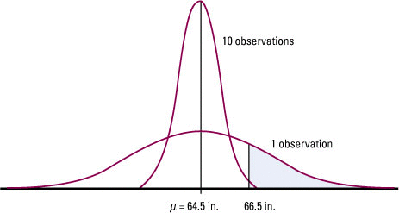

***The sampling distribution of the mean height* x *for samples of 10 young women compared with the distribution of the height of a single woman chosen at random, for Example 9.7***

# Sampling Distribution of a Sample Mean

Draw an SRS of size n from a population that has the normal distribution with mean μ and standard deviation σ. Then the mean of the sampling distribution of  is μ and the standard deviation is 

# Central Limit Theorem

Draw an SRS of size *n* from any population whatsoever with mean μ and standard deviation σ. When *n* is large, the sampling distribution of the sample mean  is close to the normal distribution N(μ,  ) with mean μ and the standard deviation is .

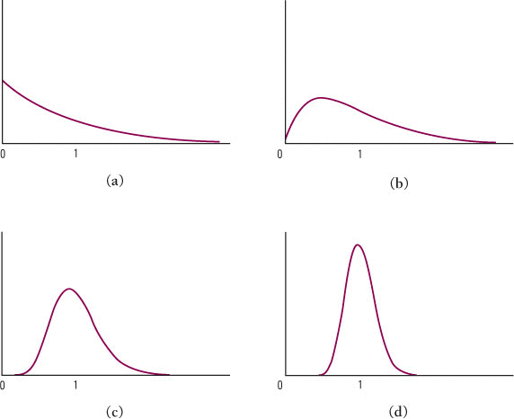

***The central limit theorem in action: the distribution of sample means* x *from a strongly non-Normal population becomes more Normal as the sample size increases. (a) The distribution of 1 observation. (b) The distribution of* x *for 2 observations. (c) The distribution of* x *for 10 observations. (d) The distribution of* x *for 25 observations***