Lesson 2-1 Density Curves and the Normal Distribution
A density curve is a curve that:
- is always on or above the horizontal axis, and
- has an area exactly 1 beneath it.

A density curve describes the overall pattern of a distribution. The area under the curve and above any range of values is the proportion of all observations that fall in that range.
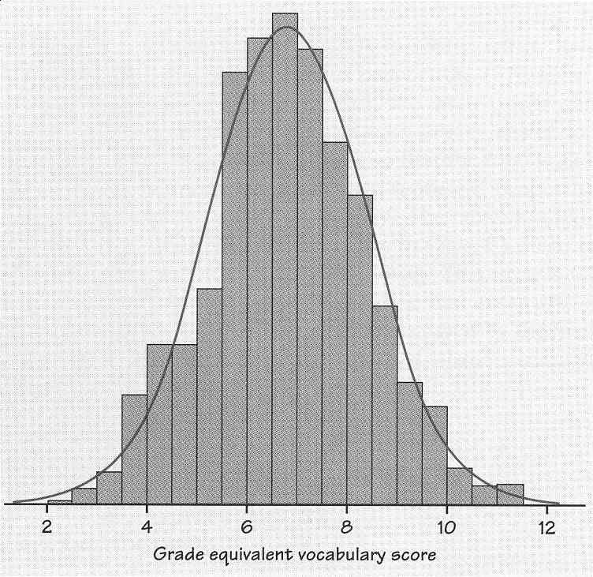
Movies seen last month
Relative frequency
.1 .2

0 2 4 6 8 10
Number of movies

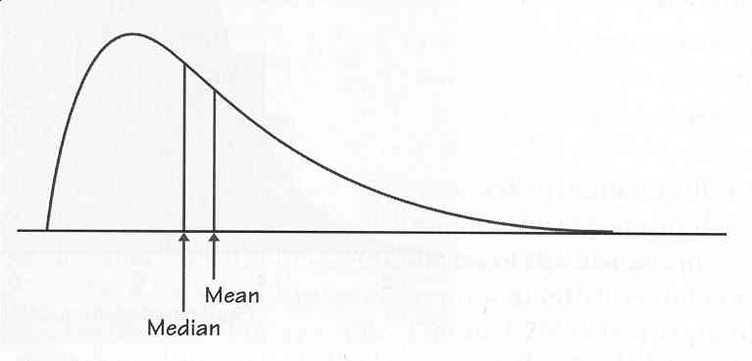The median of a density curve is the equal-areas point, the point that divides the area under the curve in half. The mean of a density curve is the balance point, at which the curve would balance if made of a solid material.

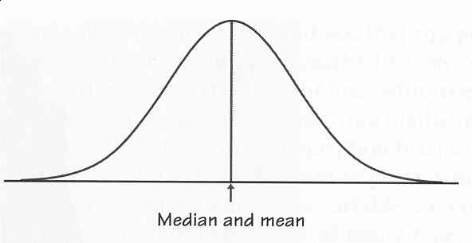The median and mean are the same for a symmetric density curve. They both lie at the center of the curve.

Because a density curve is an idealized description of the distribution of data, we need to distinguish between the mean and standard deviation of the density curve and the mean and standard deviation s of the actual data. The usual notation for the mean of an idealized distribution is μ and the standard deviation is σ.
A normal curve or normal distribution is a density curve with mean μ and standard deviation σ. All normal curves have the same overall shape. The curve is symmetric with the mean and median at the center of the distribution. The standard deviation controls the spread of the curve; curves with a larger standard deviation have more spread. A normal curve is denoted by N(μ, σ).

The 68 – 95 – 99.7 Rule (Empirical Rule)

In the normal distribution with mean μ and standard deviation σ:
- 68% of all observations fall within one standard deviation of the mean. (μ ± σ)
- 95% of all observations fall within two standards deviations of the mean. (μ ± 2σ)
- 99.7% of all observations fall within three standard deviations of the mean. (μ ± 3σ)

Working with the 68-95-99.7 Rule

- Check to see if the problem is normal or nearly normal
- Make a sketch of the normal curve
- Locate your score(s) of interest
- Interpret your answer in the context of the problem.

What Can Go Wrong?

- Don’t use the normal model if the distribution is not unimodal and symmetric.
- Don’t use the normal model if outliers are present.

